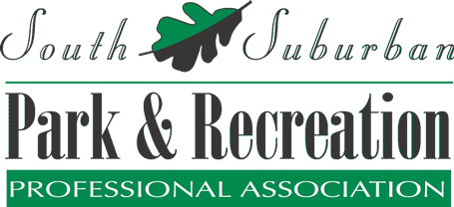

Annual Report
2022-2023
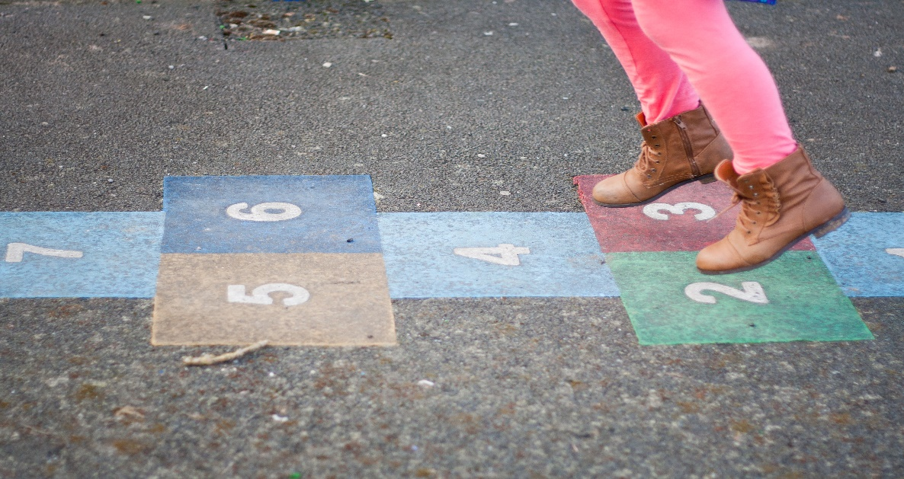

Dear SSPRPA Members,

The 2022-2023 SSPRPA year was a great success and one that everyone can be proud of. As an Association and professionals in Parks and Recreation, we have grown in numerous ways over the last year. The board, committee chairs/co-chairs, and the membership worked together to make it a successful year. Here are some highlights and accomplishments from this past year:

In September we have a social to kick off our first official meeting of the year. We gathered in Channahon at Heritage Bluffs Golf Club for 9 holes of golf. Unfortunately, the weather didn’t cooperate but hey, we’re recreation so we still made it a fun day! In November, we hosted two different educational workshops in one day with Michael Brandwein. By offering 2 different sessions people could make it an all-day event or just attend the morning or afternoon session to fit their schedule. The Executive Board was again successful in obtaining a $2,500 scholarship through IPRF to help fund the workshops. We were able to offer a total of 0.6 CEUs for a very minimal cost. In December, the social committee planned a great social event at the Alley Grill & Taphouse in Mokena.

We hosted our social at the IPRA/IAPD state conference at the Hyatt Regency at the end of January. We did a sports theme this year. February marked another successful Legislative Breakfast that SSPRPA sponsored, and we had the student meeting at Moraine Valley Community College. March brought us our Legislative Committee Chairs: Greg Lewis and Hollice Clark, presenting on the legislative process and its importance in our industry.

In April, the Awards Committee put together a wonderful program to honor those professionals who have gone above and beyond this year. We were able to give out 2 undergraduate student scholarships this year since no graduate applied. Three members of the board were able to attend the IAPD Legislative Reception and Conference in Springfield to represent SSPRPA. The Social Committee put together a great end-of-the-year social at The Rooftop in Palso Heights. Over the Summer the Day Camp Workshop Committee and Early Childhood Committee hosted two fantastic workshops for seasonal and part-time staff.

A big thank you to every one of our members for all their hard work this past year! We are looking forward to continued growth and success, as well as working with all our members to continue to achieve our mission.

Sincerely,

Olga Viano
President 2022 -2023

Mission Statement
Working together to serve members who provide communities with quality park and recreation services.

Statement of Purpose
SSPRPA is an association comprised of park, recreation, conservation and special recreation professionals, students and citizens working together to serve communities of the South Suburban Chicagoland area by providing better parks and facilities, recreation programs and services.

2022-2023 Executive Board
President – Olga Viano
President Elect – Rachel Bauer
Past President – Kevin Miller
Secretary – Stacy Proper
Treasurer – Jason Braglia
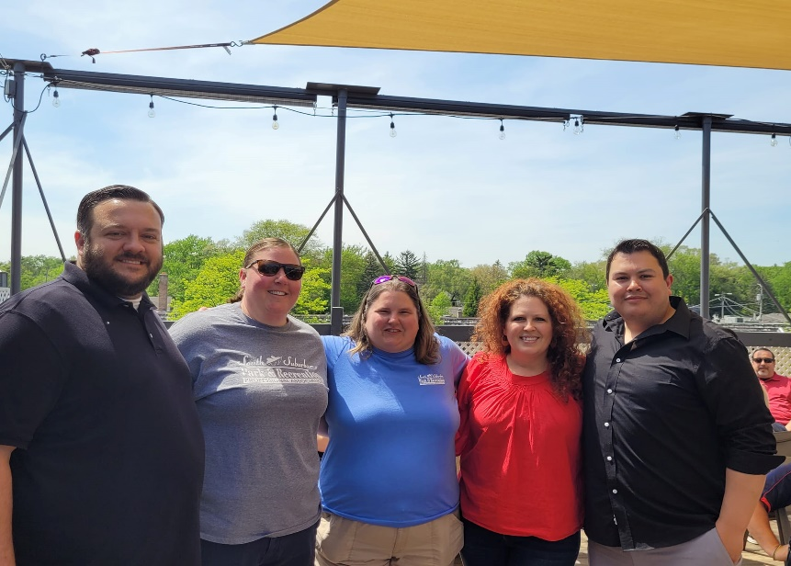
2022-2023 Committees, Chairs & Co-Chairs

Committees Chair & Co-Chairs
Adult/Senior Marie Piotrowski
Athletics Skyler Ramberger & Beth Nagel
Awards Rachel Bauer & Kristine Wahlgren
Day Camp /Teens Meghan Fenlon
Diversity Keith Wallace & Nikki Gotsch
Early Childhood Kelly Matson & Devin Frendreis
Facility Cate Coyle & Joe Smith
Legislative Hollice Clark & Greg Lewis
Professional Development Olga Viano
School Age Rebecca Perkaus & Sarah Carr
Social Lauren Koszola & Brenna Bowers
Special Events Eric Sloyan & Laurie Murray
Sponsorship Amy Maher
Student Delaney Harty & Marie Piotrowski

Membership Numbers 2017 - 2022

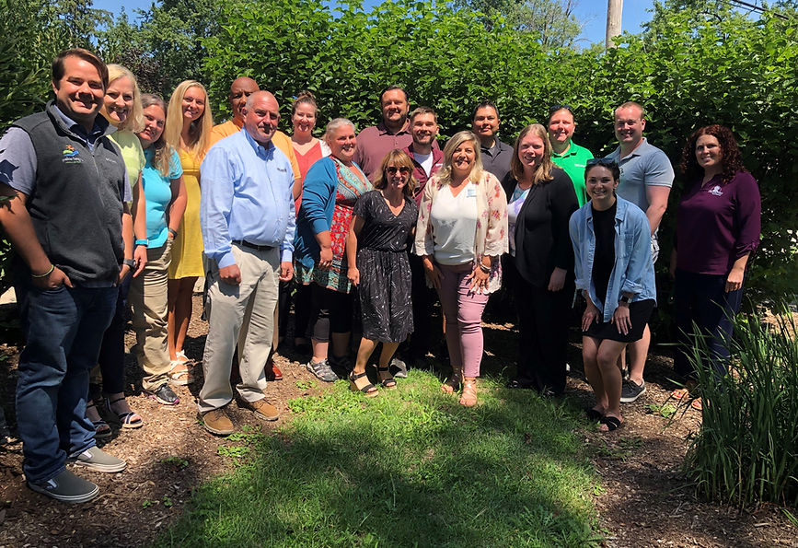
2022-2023 Participating Organizations

Alsip Park District
Bartlett Park District
Blue Island Park District
Bolingbrook Park District
Burbank Park District
Calumet Memorial Park District
Chicago Heights Park District
Chicago Southland Convention & Visitors Bureau
Chicago State University
City of Palos Heights
Community Park District of La Grange
Crete Park District
Cunningham Recreation
Forest Preserve District of Will County
Frankfort Park District
Hickory Hills Park District
Homewood-Flossmoor Park District

Joliet Park District
Kankakee Valley Park District
Lan Oak Park District
Lemont Park District
Lockport Township Park District
LWSRA
Manhattan Park District
Midlothian Park District
New Lenox Community Park District
NuToys Leisure Products
NWCSRA
Oak Forest Park District
Oak Lawn Park District

Park District of La Grange
Peotone Park District
Plainfield Park District
Pleasant Dale Park District
Proven IT
Record-A-Hit Entertainment
Romeoville Recreation Department
SEASPAR

South Suburban Special Recreation Association
South West Special Recreation Association
Tinley Park-Park District
Upland Design Ltd
Village of Orland Park
Village of Palos Park
Warrenville Park District
Westchester Park District
Wight & Company
Wilmington Island Park District
Worth Park District

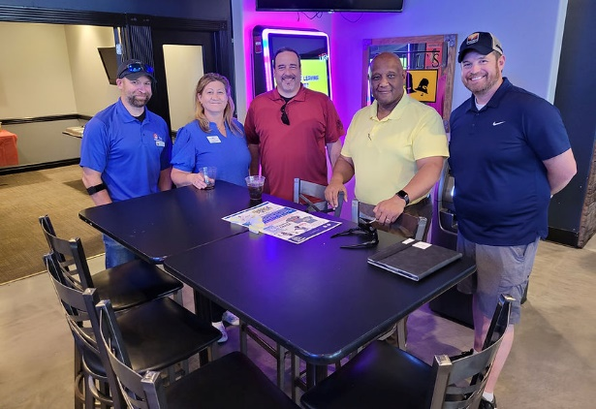
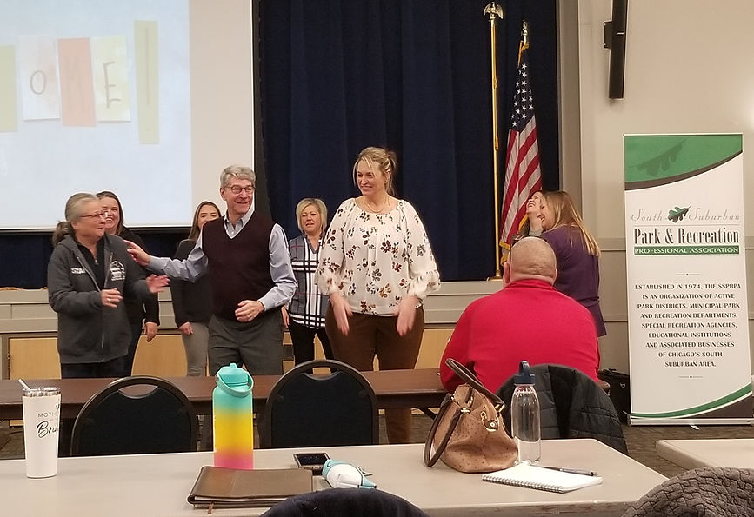

SSPRPA Financials
Starting Balance – September 2022 =$17,239.84
Starting Balance – September 2023 = $18,989.08

2022-2023 Actual Budget
Total Revenue = $31,084.13
Total Expenses = $32,541.62

Revenue Totals
Membership Fees = $8,320
Meeting Fees = $4,155
Sponsorship = $1,500
IPRA Social = $2,025
Day Camp Workshop = $2,310
Early Childhood Workshop = $480

SSPRPA Strategic Plan
Strategy 1
Evaluate and update the use of digital media to enhance member service.
- Create a newsletter to be sent out to the memberships on at least a quarterly basis. (2018)
- Include links to Facebook, website, and other pertinent information in correspondence. (2018)
- Create an online payment option for meetings, membership, events, and sponsorships. (2019)
- Optimize the website for mobile use. (2018)
- Survey member needs and opinions of website and digital use (annually)
Strategy 2
Provide orientation and training for committee chairs to help provide structure to committee operations.
- Create and schedule Board and Committee chair retreat
  - Review and update operations manual
  - Introduce and train chairs and new board members on the budget process
  - Review and train proper financial procedures
  - Schedule committee meetings for the year to combine and or prevent duplication of meetings and content
  - Review with chairs the importance of reports at meetings
- Create committee intent categories on memberships registration forms so that information can be sent to members based on their interest
  - Start strategy 2 summer of 2018, making improvements each year.

Strategy 3
Offer efficient and effective meetings that provide useful learning opportunities and networking for members.
- Continue to provide professional speakers and programs that provide relevant topics
- Require all board, chairs, and speakers to stand so that all members can hear them during the meeting
- Inform members in advance when CEU programs will extend the overall length of a meeting
- Start all meetings on time
- Provide nametags at meetings so that members can learn each other’s names easier
- Assign members to tables periodically to encourage members to network with others that are not from their agency
- Continue to offer general meetings at different locations and search for new facilities to host
- Continue to offer lunch at meetings
- Educate members on the availability of using the announcement portion of general meetings for the benefit of the membership or their agency.
  - Strategy 3 will be ongoing, this information can effectively be shared with members via communication goals. (2018-2021)
Strategy 4
Create an organizational annual benchmarking report in order to show the current trends, strengths, and challenges of South Suburban Parks and Recreation Professional Association. (2018-2021)
- Track total annual membership
- Track meeting attendance
- Track active members
- Track special event attendance
- Track Sponsorships
- Track committee involvement
Each year this report should be made public to the membership during the summer months, and should be continually reviewed and expanded upon.
SSPRPA
2022-2023 Award Winners

Professional of the Year
Joe Smith
Palos Heights Park and Recreation Department

Young Professional of the Year
Marie Piotrowski
Lemont Park District

Undergraduate Scholarship
Reily McTeague and Lindsey McArdle
Moraine Valley Community College

Congratulations to the new board members voted into service for the start of 2023 SSPRPA: Sarah Hamilton: President Elect, Lauren Koszola: Treasurer and Delaney Mossman: Secretary. Rachel Bauer moves into the President position and Olga Viano moves to Past President for 2023-2024.
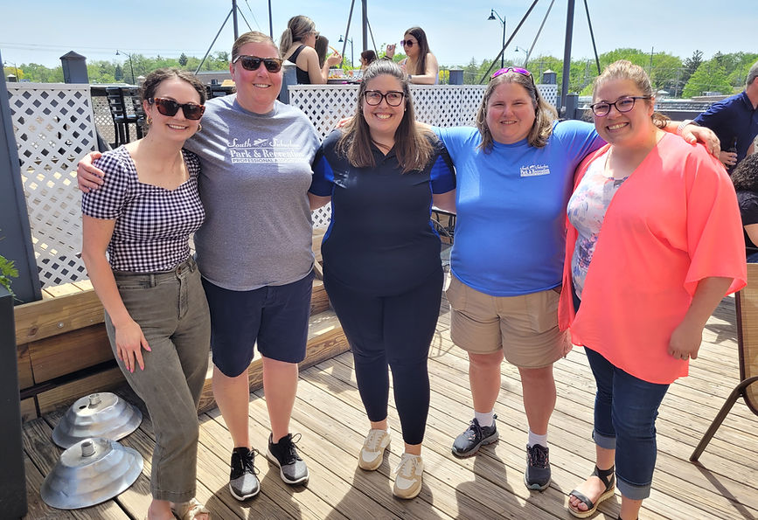
Thank you to all our Sponsors in 2022-2023!!

Meeting Sponsors:
January – Midwest Commercial Fitness
March – Chicagoland Southland CVB & Sparkles Entertainment
April – Midwest Commercial Fitness

Social Sponsors:
Holiday – T-Mobile (Gold)
End of Year May – Civic Plus (Silver)

Day Camp Sponsor – Emagine (Bronze)




