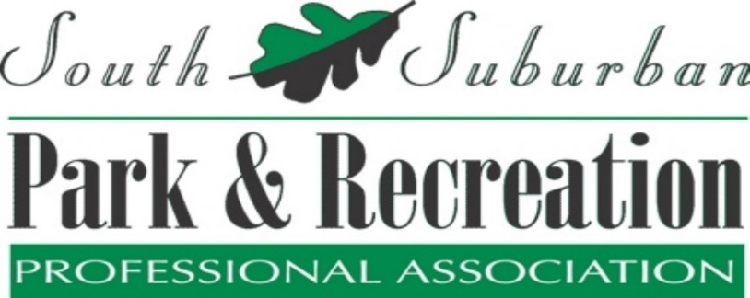

For more information visit our website:
www.SSPRPA.org

Date: | Location: | Education/Event:
September 12, 2024 | Facility TBD | Member Social
October 17, 2024  *Meeting Moved to 3rd Thursday due to National Conference | Stoney Creek Golf Course – Oak Lawn | Squirrel!! Staying focused with a coworker who has ADHD
November 14, 2024 | Alsip Park District | Artificial Intelligence
December 12, 2024 | Facility TBD | Member Social
January 9, 2025 | Palos Heights Park and Recreation | Is your Park District gay enough?
February 13, 2025 | Calumet Memorial Park District | Educational Session TBD
March 13, 2025 | Bolingbrook Recreation & Aquatic Center (BRAC) Facility | Legislative Update
April 10, 2025 | Facility TBD | Awards Banquet
May 8, 2025 | Facility TBD | Member Social

Looking Forward to Celebrating 50 Years of SSPRPA in 2024 - 2025!

