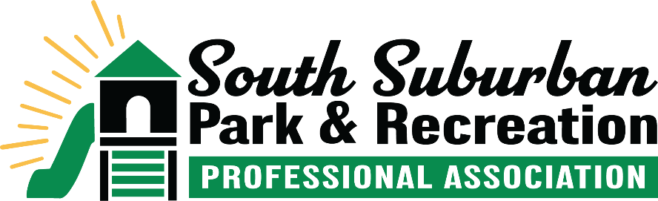
Awards and Recognition Program

The South Suburban Park and Recreation Professional Association has created an Awards and Recognition Program for park and recreation professionals. It is the intention of SSPRPA to recognize the individual who demonstrates the “vision” to achieve excellence in leisure programming and service. The criteria for each award are listed below.

Awards and Milestone Certificates will be presented at the SSPRPA Awards Ceremony on April 9 at Mokena Community Park District – Yunker Farm.

To be considered for Young Professional or Professional of the Year, two things are required to apply. One of these two must come from the current supervisor or Executive Director of the agency. Self-nominations are allowed.
- A narrative specifically explaining why the candidate meets the qualifications
- A letter of reference

Nominations and milestones are due to the Awards Committee Chair Rachel Bauer at rbauer@palosheights.org by Monday, March 16, 2026.

SSPRPA Member Milestones (years in the field or at the agency)

SSPRPA Member Milestones will be recognized during the SSPRPA Awards Program. Milestones should be achieved between April 1, 2025 - April 1, 2026 and can be for total years of service in the field or for total years at current agency. Please send us their information (agency, title, years of service to field or agency). Candidates should have been in the park and recreation field for 5, 10, 15, 20, 25, 30 or more years. SSPRPA would like to recognize our members in their milestone year.

Young Professional of the Year

This SSPRPA Award recognizes an individual who demonstrates potential in making significant contributions to the park and recreation profession. This award comes with a $500 education scholarship from the Wilson Family Public Servant Fund.

Candidates for the Young Professional of the Year must meet the following criteria:
- Individual must be a current SSPRPA member
- Served a minimum of one (1) year but fewer than eight (8) years full time as a park and recreation professional
- An active member of an SSPRPA committee (Active means contributing to their committee through meeting attendance and/or email conversations
Candidates for the Young Professional Award must meet a minimum of six of the following criteria:
- Volunteered for SSPRPA event(s)
- Attended 4 or more SSPRPA general meetings in one year.
- Demonstrated a commitment and promotion of the park and recreation movement within the candidate’s local community
- Achieved notable success within the candidate’s agency
- Hold a certification that maintains continuing education credits or units
- Demonstrated leadership qualities
- Additional professional certifications that enhance and/or benefit the local agency
- Professional involvement in Illinois Park and Recreation Association (IPRA), Illinois Association of Park Districts (IAPD) and/or National Recreation and Park Association (NRPA) committees
- Attends workshops, conferences, webinars, or other educational sessions to further their education during the past SSPRPA year (September – March)
- IPRA membership

Professional of the Year

This SSPRPA Award recognizes an individual who has created awareness of the importance of parks and recreation among their communities and must have made a significant impact within an SSPRPA agency from the previous year. This award comes with a $500 education scholarship from SSPRPA.

Candidates for the Professional of the Year must meet the following criteria:
- Individual must be a current SSPRPA member
- Served for eight (8) or more years full time as a park and recreation professional
- An active participant on an SSPRPA committee (Active means contributing to their committee through meeting attendance and/or email conversations)

Candidates for the Professional of the Year must meet a minimum of six of the following criteria:
- Made a notable contribution to SSPRPA by serving in the capacity of a current or former committee chairperson or by serving on the Executive Board
- Attended 4 or more SSPRPA general meetings in one year
- Hold a National Certification that maintains continuing education credits
- Dedication and experience in developing quality parks, facilities and recreation services for the agency they serve
- Accomplishments achieved as a professional benefit the agency they serve
- Professional involvement in Illinois Park and Recreation Association (IPRA), Illinois Association of Park Districts (IAPD) and/or National Recreation and Park Association (NRPA) committees
- Demonstrated leadership qualities
- Recognizable achievements and service of the Park and Recreation field within the candidate’s local community
- Additional professional certifications that benefit the local agency
- Attends workshops, conferences, webinars, or other educational sessions to further their education during the past SSPRPA year (September – March)
- IPRA membership

